*Florida International University*

*School of Computing and Information Sciences*

CIS 4911 - Senior Capstone Project

Software Engineering Focus

Feature Document

User Story #592

**Team Member:**

Andrew Mitchell

**Product Owner(s)**:

Francisco R. Ortega

**Mentor(s)**:

Francisco R. Ortega

...

**Instructor**: Masoud Sadjadi

# 

# **User Story – Implement Basic Feedback for Multitouch**

* As a User I would like feedback when I change from various modes using the multitouch and its UI so I can tell what functionality I can expect when I draw on the multitouch.

## **Use Case – View Mode Box**

Use Case

Be able to tell which draw modes we are currently on. This includes implementing some basic UI buttons to implement since we want the buttons to also register with the mode box.

Details:

Actor: User

Pre-conditions:

Program must be running. Multitouch must be working. EyeX must be working if you want gaze functionality.

Description:

Use case begins when the user starts up the application. The user then receives visual feedback based on which mode they are on using the ‘Mode’ box on the bottom right. They also receive a few visual buttons they can look at. EyeX gaze is optional, if the eyeX is plugged in it will require the user to look in the direction of the buttons to see the UI.

Post-conditions:

Box must show the user exactly what they are drawing, including colors, shape, and whether the object is filled or not.

Decision Support:

Frequency: Very often. The user may forget the current mode if they are not currently drawing. A nice intuitive box will prove a great reminder.

Criticality: High. It is very important to know which shapes or colors we are about to draw with incase the user forgets. Very key in drawing.

Risk: Low. Fairly simple to implement, should just be about how much time it takes, not necessarily ‘can we do it?’

Reliability: Highly.

Mean time to Failure – Never. It should always represent the proper modes.

Availability – Mode box is always available without EyeX. With eyeX it should be available when we look into the bottom right 20% of the screen.

Performance:

N/a

Supportability:

Must work with ACER Multitouch.

Tobii EyeX

Modification History:

Owner: Andrew Mitchell

Initiation date: 02/28/2016

Date last modified: 02/28/2016

**Mode Box Use Case**

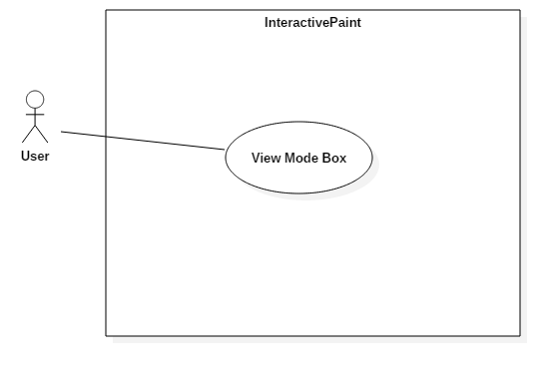

## **Sequence Diagram**

## 

## 

## 

## 

## 

## **Class Diagram**

## C:\Users\IEatR\Pictures\Mode Box Class.png

## 

## **Unit Test**

Sunny Day :

Updated :

After failure to erase previous shapes we now have a working test.

* ‘Gaze’ at the bottom right of the screen
  + Mode box successfully appeared.
* Change to line draw mode from circle mode
  + Successfully drew all 3 lines. Removed circle.
* Change to Circle draw mode.
  + Drew the circle
* Enable fill mode
  + Circle became full
* Change color
  + Correctly changed through colors
* Draw with red circle in mode box
  + Successfully drew red circle in the canvas.
* Enable eraser mode
  + Correctly made the proper sized eraser in the mode box.
* Switch to triangle mode
  + Correctly drew the triangle
* Switch to rectangle mode
  + Correctly drew rectangle in mode box.
* Switch to non-filled shapes
  + Rectangle correctly unfilled
* Change line size
  + Line size Dynamically changed.
* Look away from bottom right
  + Mode box successfully shut off.

Rainy Day Tests :

* Hold down color change key
  + Correctly runs through all colors correctly. Draws with the same color as mode box at the end of the key down.
* Hold down line size key
  + Lines grew dynamically and correctly.
* Press button while EyeX gaze is not looking at them
  + Buttons did not activate changing shapes or colors.

## 

## **Integration Test**

Works with current ‘touchpoints app’. Correctly identifies which modes we are in. Showing us the current shape, whether it is filled or not, and what color it is. Also shows eraser mode. Works with all of the new implementation with Garretts Leap Motion changes.

The mode box is now integrated with the device Modes button

The mode box now contains the Settings menu as well.

## 

## **User Guide**

Start up the application. If the EyeX is running point your gaze to the lower right corner of the screen to bring up the mode box. If the EyeX is not running the box will simply show at the bottom right of the screen. Additionally the buttons will be available at the top left of the screen. If the EyeX is enabled your gaze must go to the top left of the screen to show the buttons as well as enable them for clicking.

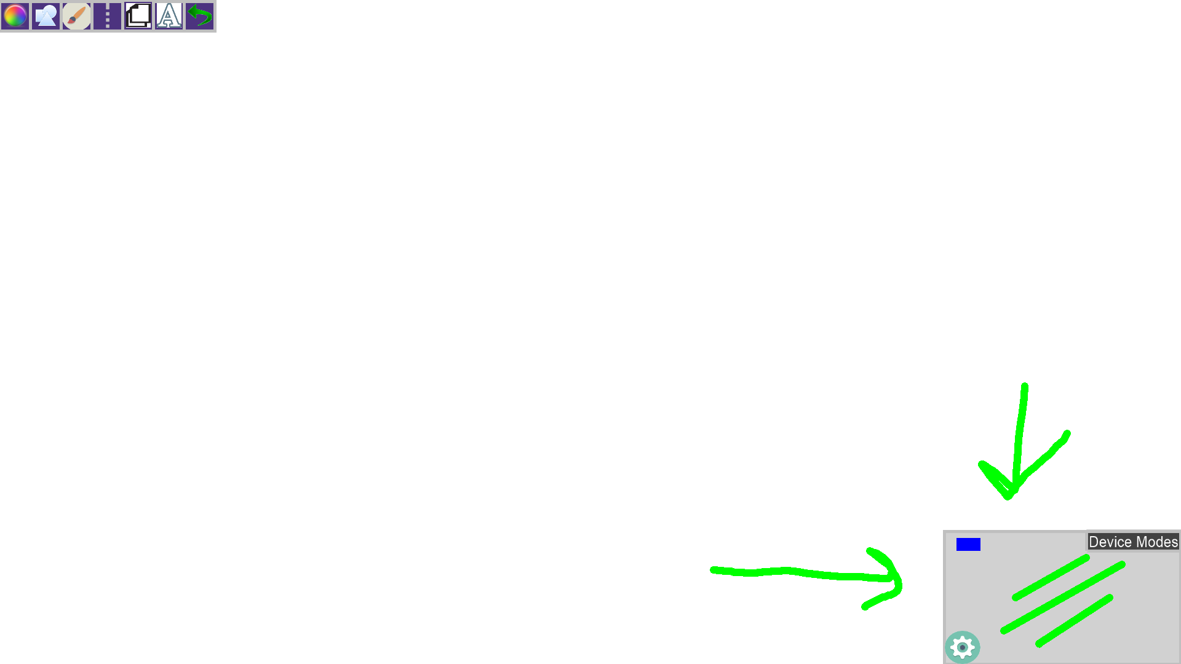This image shows the mode box with the current lines we are drawing (Green lines of a certain size)

We can change shapes, line size, and toggle on and off filled shapes. We can see the effects of some of these modifications in the images below.

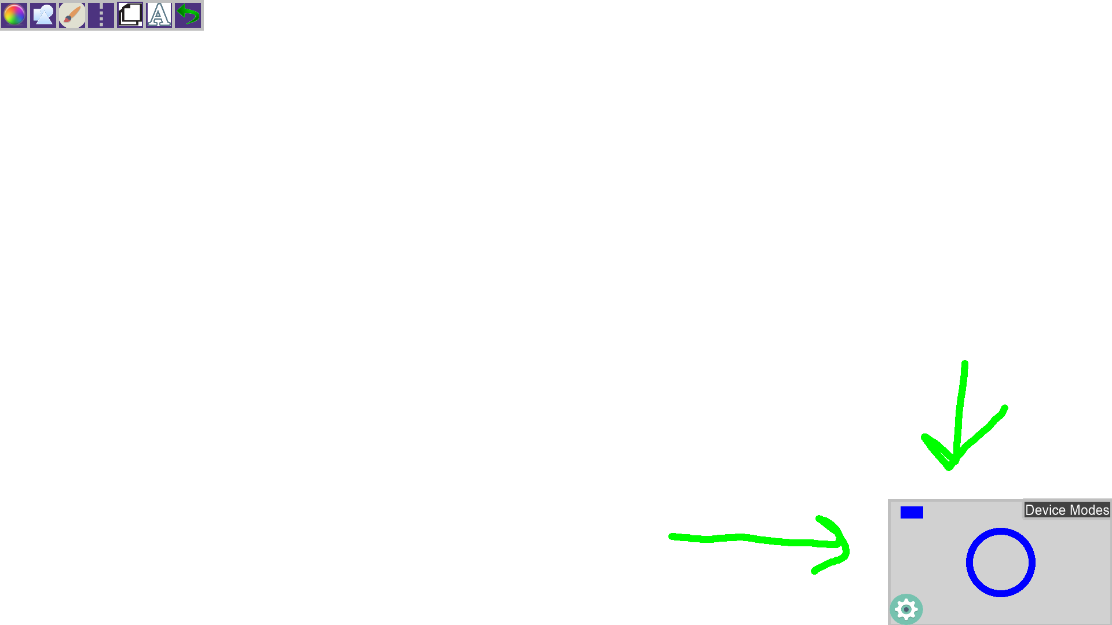

Blue Hollow Circle

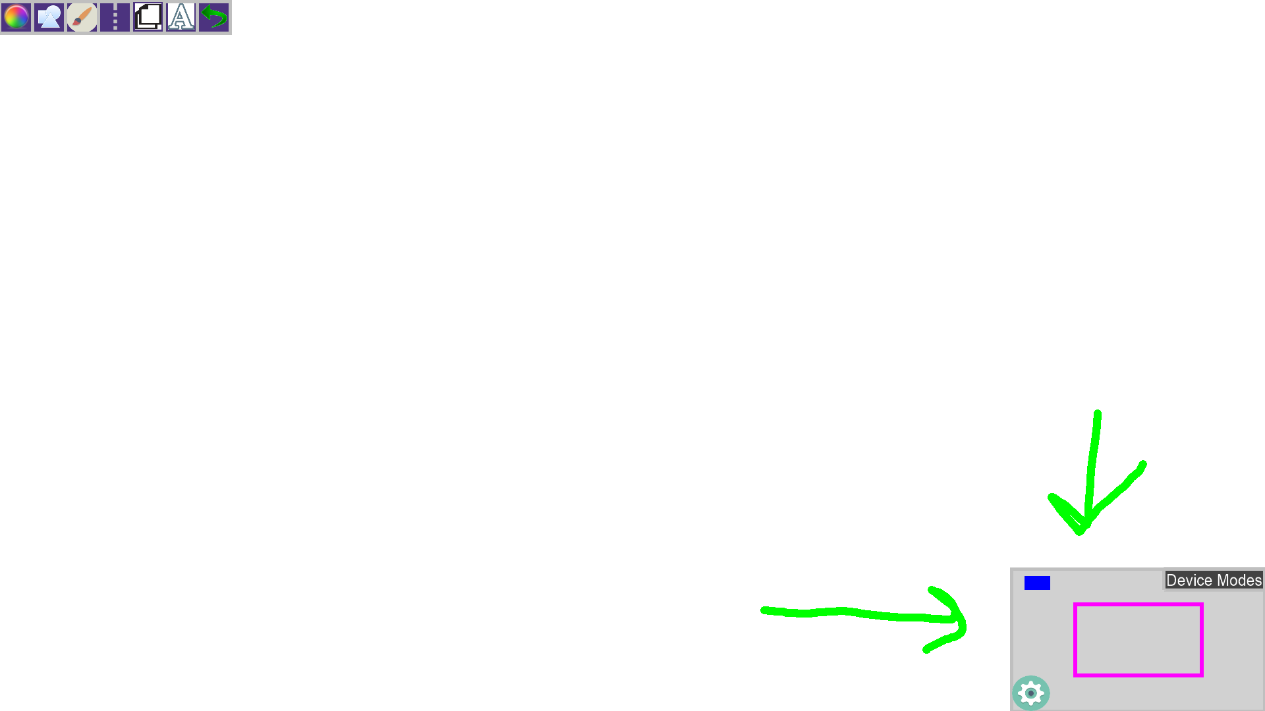

Purple Hollow Rectangle

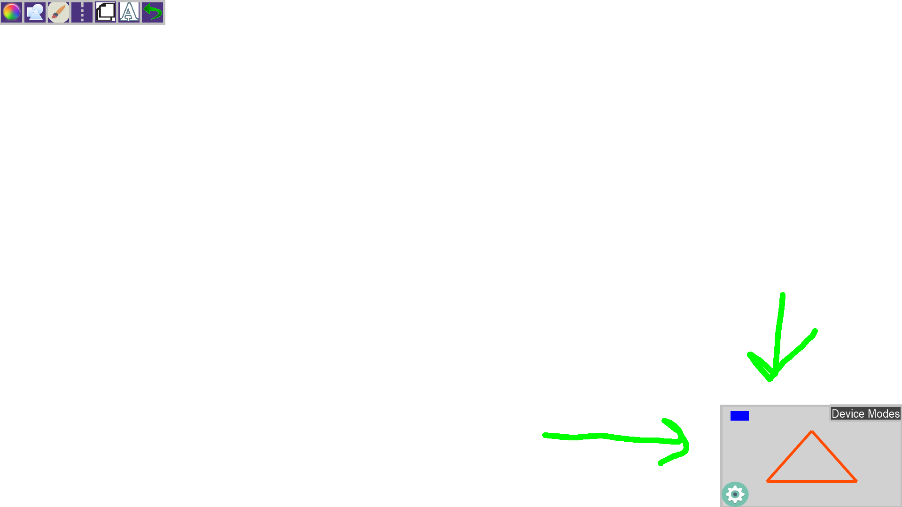

Orange Hollow Triangle

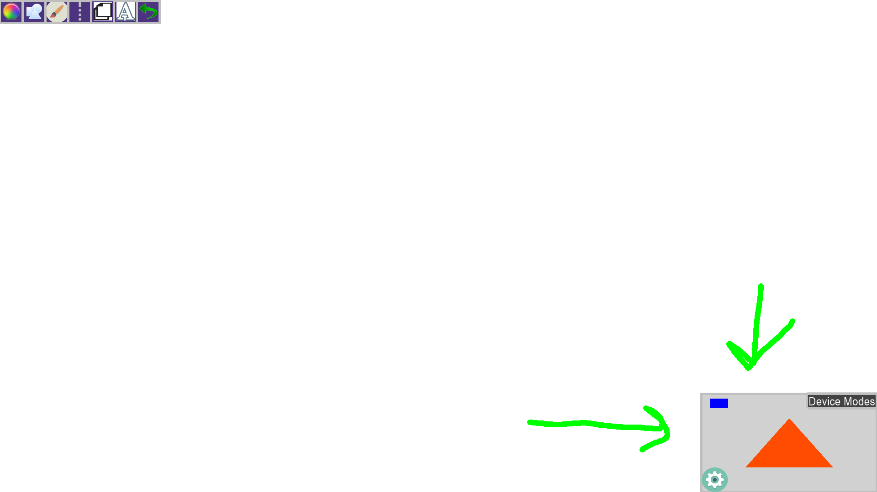

Orange Filled Triangle

**Glossary**

Mode Box - Box located in the bottom right of the screen. It displays device statuses as well as showing you the color and shapes you will be drawing.